**Project management plan:**

**1. Overview:**

**1.1 Purpose:** The purpose of this application is to let the user to take quiz in the Project management quality area and 3 process groups and helps to increase their knowledge.

**1.2 Scope**: This application mainly focuses on the development of the quiz app for the Project management quality area and 3 process groups and further we may add other quality areas to this application.

**1.3 Objectives:** To develop the quiz app for the project quality management.

**1.4 Constraints:** Getting all the data for the quiz and to make them available to the customer.

**1.5 Assumption:** This application helps user to increase their knowledge in the Project management quality area.

**1.6 Constraints:**

* This project has to be completed in 90 days which is kind of busy schedule to complete all the tasks.
* Quality of the project will be affected due schedule constraint.

**1.7 Project deliverables:** Project charter, project management plan document, scope statement, work breakdown structure, Gantt charts, cost management plan, stakeholder register, status reports, issue log, final project documentation, end product which all customer requirements and functionality .

**1.8 Schedule:**

|  |  |  |
| --- | --- | --- |
| SNO | PROCESS | DAYS |
| 1 | Initiation | 7.37 days |
| 2 | Planning | 23.625 days |
| 3 | Execution | 33 days |
| 4 | Monitoring and Controlling | 4.625 days |
| 5 | Closing | 2.625 days |

**2. Project organization:**

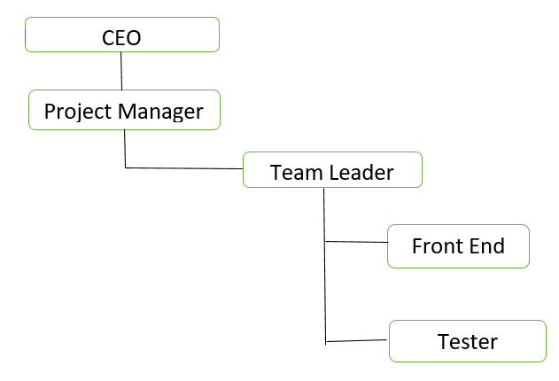

**2.1 External interfaces**

* customer
* We are using Apache Tom cat server for publishing the application.
* There are no sub contracted organizations for this project.

**2.2 Roles &Responsibilities:**

|  |  |  |
| --- | --- | --- |
| **Name** | **Roles** | **Responsibility** |
| Sathwika Gone | Team Manger | Plans schedule ,working with team and sponsor |
| Nandini Doppalapudi | Team lead | Guides the employees to complete the projects, assigning tasks to employees, motivating employees |
| Susritha Gade | Front end developer | Creates an interface through which user can interact. |
| Rakesh Avirineni | Tester | Tests the interfaces so that everything is working correctly |

**3. Managerial Process Plan:**

**3.1 Startup plans:**

This project approximately takes 15 days to complete with a budget of $2500 where manager, team lead, front end developer and tester will be working who will be trained for 1 day (where they will be introduced to process of developing the application).

**3.2 Work plan:**

|  |  |  |
| --- | --- | --- |
| Work Activities | Schedule | Budget Allocation |
| Requirements gathering | 10 days | $10,000 |
| Design Delivery | 15 days | $12,000 |
| Development | 25 days | $25,000 |
| Testing | 12 days | $13,000 |
| Launch application | 3 day | $6,310 |

**4. Technical Process Plan:**

**4.1. Process Model:**

**4.1.1 Project Initiation:**

**4.1.1.1 Project Charter:**

Project Title: PM Tutorials

Project Start Date:05/17/2019

Project Objectives: This is a web application that allow user to take the quiz on project quality management knowledge area and three process groups (Planning, executing and monitoring and controlling)

**Roles and Responsibilities:**

|  |  |
| --- | --- |
| **Name** | **Roles** |
| Sathwika Gone | Team Manger |
| Nandini Doppalapudi | Team lead |
| Susritha Gade | Front end developer |
| Rakesh Avirineni | Tester |

This project has met the business requirements like it gets more amount than that is invested, increases the level of the company through developing quiz app as it reaches many clients.

**4.2 Project Planning:**

**4.2.1 Cost estimate:**

The approximate cost estimate of this project is $66,310.

* WBS items-$10,500
* Hardware-$8010
* Software-$1500
* Testing-$1200
* Training and support-$35,600
* Reserves-$9,500

**4.2.2 Staffing:**

|  |  |
| --- | --- |
| **Name** | **Roles** |
| Sathwika Gone | Team Manger |
| Nandini Doppalapudi | Team lead |
| Susritha Gade | Front end developer |
| Rakesh Avirineni | Tester |

**4.3 Executing:**

**4.3.1 Work Breakdown Structure:**

**1. Initiation**

Identify the Stakeholders

Select the project Manager

Form a project Team

Prepare a Project Charter

Approval of Project Charter

Review Project Charter

**2. Planning**

Develop a scope statement

Develop a Work Breakdown Structure

Develop Requirement Management Plan

Develop Project Management Plan

Managerial Process Plan

Technical Process plan

Develop Requirement Traceability Matrix

Develop Project Time Management

Develop schedules

Resource Allocation

Develop Cost Management Plan

Cost Estimation and Determine Budgets

Develop Quality Management Plan

Develop Human Resource Management Plan

Develop Communication Management Plan

Develop Risk Management Plan

Develop Procurement Management Plan

Develop Stakeholder Management plan

Approval of all plans

**3. Execution**

Design Prototypes

Approval and review of prototypes

Developing website

Create Registration page

Create Login page

Create Quiz screens

Create Score screen

Perform quality assurance

Testing

Unit Testing

Integration Testing

System Testing

User Acceptances testing

**4. Monitoring and Controlling**

List the defects in the system

Change requests

Update the Plan

Track status of defects

**5. Closing**

Lessons Learned

Demo of the project

Final project delivery to clients

**4.3.2 Project Schedule and Time management:**

We will prepare schedule for the complete project by considering each and every team members capability, performance and also time required in order to train team members on the new technologies that are being used in the project.

**4.3.3: Project Human Resource Management:**

Based on the project requirements we need around 10 members to complete the project successfully. As our project needs people who work on technologies like html, CSS, java script and data base so we choose people who had good amount of experience and had been part of different projects of respective technology. Then after acquiring the required people we will allocate the work according to their skills and measure their performance by allocating them the work and giving them the deadlines and check whether they are completing the task on time if they cannot complete it on time will try to know what is the problem and try to help him in completing the task. If he completes the work on the time then we would appreciate the employee in the scrum meeting as appreciation gives us new energy.

**4.3.4 Project Procurement Management and Budget Allocation:**

We will buy selenium testing tools in order to test the website performance and whether the website is properly working or not. We allocated 1200 $ to buy different testing tools.

**4.3.5 Project Management and control:**

We allocate a person to take the role of monitoring of all the work whether the work is going according to the schedule and if the work is being delayed then he will take the necessary steps to make sure that the work finishes on time and the same person takes care of the budget and make sure the money is not being wasted and the budget does not go beyond the expectation.

**4.3.6 Project Quality Management:**

We will setup some policies and guidelines and make sure very member in the team follow them and work accordingly.

**4.3.7 Project Communications Plan:**

We will communicate through skype calls and if there is any emergency and if any team member is not available we will have a virtual meeting through skype and we even use some of the tools like screen sharing apps like join me and show my pc to work virtually if needed.

**4.3.8 Project Closure:**

We make sure the requirements given by the project sponsor and arrange a meet with the sponsor and explain about the website and handover the performance results to the sponsor.

**5. Supporting process Plan:**

**5.1 Configuration Management Plan:**

We will have a collection of formal documents which specify the initial baselining of work products, logging and analysis of work products, change control board procedures and tracking of changes in the progress.

**5.2 Verification and Validation Plan:**

We specify the verification and validation of techniques, scope, mile stone reviews and progress of the project

**5.3 Documentation Plan:**

We specify different types of documents that are to be prepared in different parts of the project and have proper template and proper review for each document that has been prepared.

**5.4 Quality Assurance Plan:**

We make sure that all the requirements which are mentioned by the sponsor are met according to the IT standards, procedures and guidelines.

**5.5 Reviews and Audits:**

We will have timely reviews regarding the works that is being done in the project and make sure that the review is being done according to the specific guidelines and the budget audit all the bills that are submitted regarding the project work.

**5.6 Process improvement Plan:**

We keep a backup for every procedure that is being implemented in the project if any of the procedure that is being executed does not follow the guidelines or standards then we will implement another procedure which is kept as backup for the initial procedure that is to be implemented.